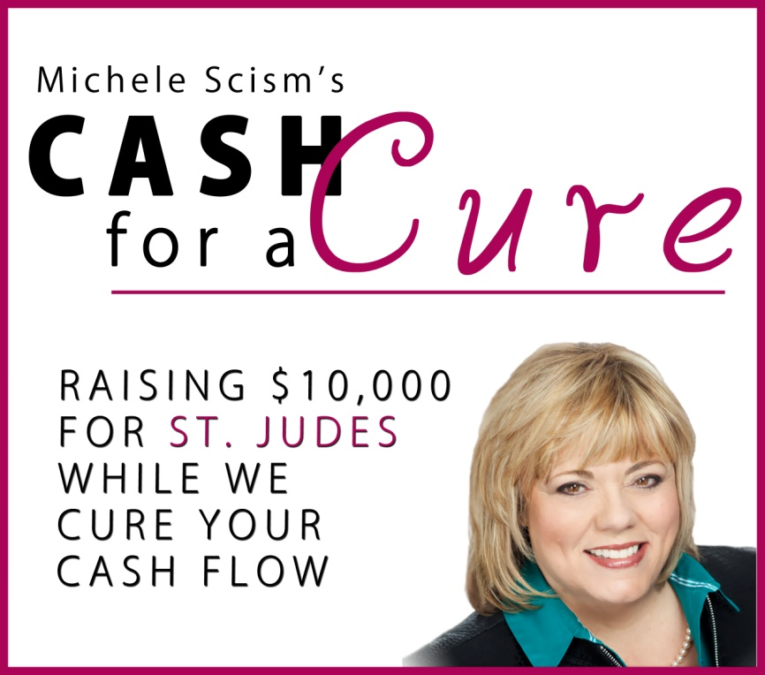

www.CashForACureEvent.com

LiveStream Event March 14, 2014

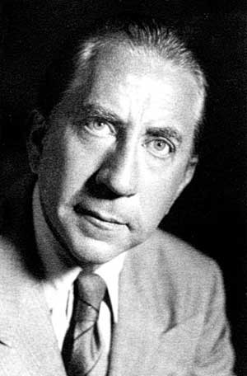

“If you can count your money, you don’t have a billion dollars.”

- J Paul Getty

Copyright and Disclaimer

COPYRIGHT 2014 DECISIVE MINDS, LLC & MICHELE SCISM. The materials and resources contained in this manual are the property of Decisive Minds, LLC, Michele Scism and the participating Faculty Members. They are available for your use as the Cash For A Cure event participant. No part of this book and ancillary documents and resources can be stored, reproduced or transmitted in any form or by any means (electronic, photographic or mechanical), recorded, translated or used to produce any derivative works without explicit permission from Decisive Minds, LLC, Michele Scism and/or participating faculty members. All Rights Reserved. Not For Resale.

Published by:
Decisive Minds, LLC
4845 Lake Street PMB #125
Lake Charles, LA 70605
337-419-1860

LEGAL NOTICES, EARNINGS AND INCOME DISCLAIMER

While all attempts have been made to verify information provided in this book and its ancillary materials, neither the author, the publisher, nor the contributing faculty members assume any responsibility for errors, inaccuracies or omissions. Any slights of people or organizations are unintentional. If advice concerning legal or related materials is needed, the services of a qualified professional should be sought.

This book and the ancillary materials are not intended for use as a source of legal or accounting advice. Also, some suggestions made in this book and its ancillary materials concerning marketing, prospecting, referrals, time managements, etc., may have inadvertently introduced practices deemed unlawful in certain states and municipalities. You should be aware of the various laws governing business transactions or other business practices in your particular geographical location.

As with any business, your results may vary, and will be based on your individual capacity, business experience, expertise, and level of desire. There are no guarantees concerning the level of success you may experience. The testimonials and examples used are exceptional results, which do not apply to the average purchaser, and are not intended to represent or guarantee that anyone will achieve the same or similar results. Each individual’s success depends on his or her background, dedication, desire and motivation.

There is no assurance that examples of past earnings can be duplicated in the future. We cannot guarantee your future results and/or success. There are some unknown risks in business that we cannot foresee which can reduce results. We are not responsible for your actions.

The use of our information, products and services should be based on your own due diligence and you agree that our company is not liable for any success or failure of your business that is directly or indirectly related to the purchase and use of our information, products and services.

What You Will Learn

Today’s objectives:
- __________________________________________________________________________________________________
- __________________________________________________________________________________________________
- __________________________________________________________________________________________________
- __________________________________________________________________________________________________

Three Reasons Your Cash Flow is in Crisis!
- ___________________________________________________________________________________________________________________________________________________
- ___________________________________________________________________________________________________________________________________________________
- ___________________________________________________________________________________________________________________________________________________
Michele’s Sales FACTS:

1. You make _________________ until you sell something.

2. You can make money today if you understand the concept of ________________________________________

3. There are 3 things you can sell TODAY:
- Your ______________________
- A _________________ you have _____ yet created
- Another ________________ product as an affiliate

4. At this point in time, with this economic environment, the fastest way to make money is with a ___________________ conversation.

“I think the 1st hurdle that holds entrepreneurs back is that they aren’t sure what they are selling. They might not have a physical product in their hand to sell and that can stop you from having sales conversations.”
Michele Scism
Where is your “low hanging fruit”?

What is it that you can sell today? This may actually be contradicting to what you hear a lot of other business coaches preaching but I believe you have to sometimes continue to be the do-er, do the one on one coaching, provide the va services, be the social media manager until you can get to the point where you are making enough money in your leveraged business for it to become your main focus.

1. You could sell your Knowledge!

The information products business is a multi Billion dollar industry. People sell their knowledge on a daily basis. You are here learning from me – you are purchasing my knowledge.

What knowledge do you have that others want? What is that people always ask you to do because it just comes natural for you? Oprah and Tony Robbins have made Millions or Billions selling their knowledge and other people’s knowledge.

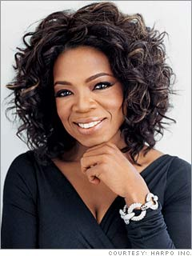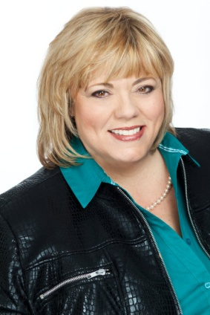

2. You could sell products you haven’t created yet!

OK, for a lot of entrepreneurs this is a scary one. I actually created a program to teach people how to do this one.

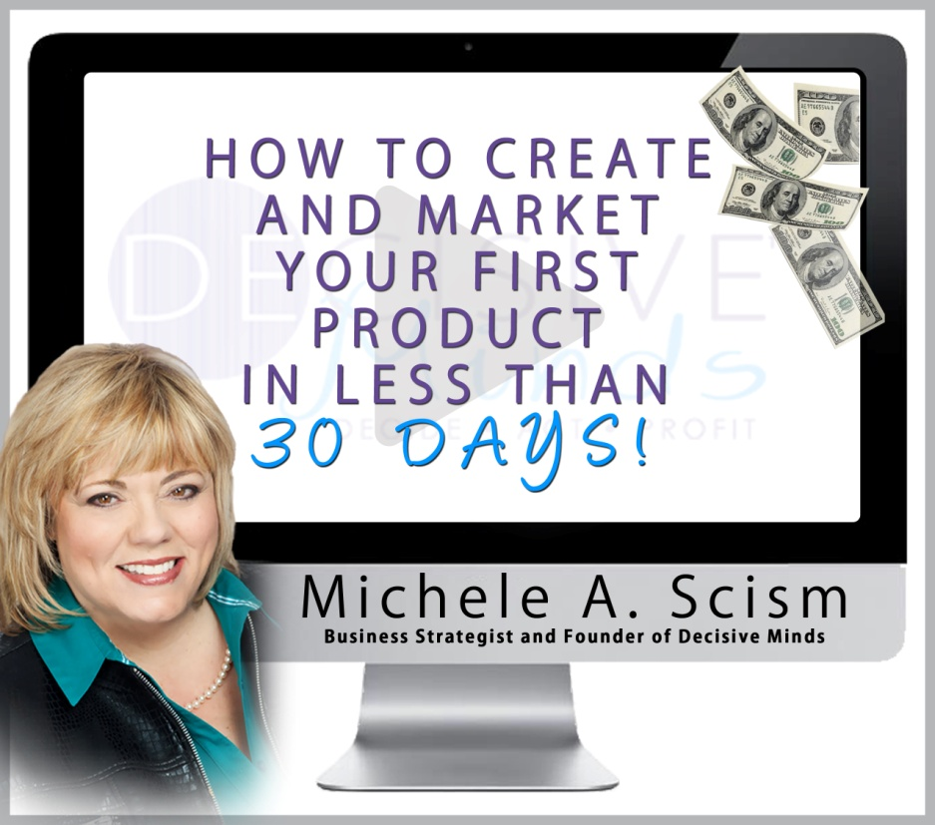
www.TakeActionGetProfits.com/Create

This might be hard to wrap your brain around.

NEVER create a product before you sell it.

As entrepreneurs we got lots of great ideas! The question is are they all going to sell? Do you want to waste your time creating something that doesn’t sell?

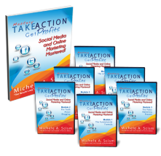
www.TakeActionGetProfitsMastery.com

Take Action Get Profits Mastery
What I knew was that people wanted more social media training. They were hungry to know how to do it themselves so I decided to create a program to show them how I used social media to build my 6 figure business.

Results:

We set the Introductory Price $397

Prior to creating the product we sold 75 units so that means we had Total Sales of $29,775. Since then we have sold an additional 30 copies.

This was a 6 module program so I created and delivered it over a 6 week period.

Easy Info Products

Why have informational products!

- Gain trust and easily attract new prospects with no to low cost info products.
- Gain credibility and authority. Info products can immediately give you credibility and easily build your expert status!
- Differentiate yourself from your competitors
- Increase referrals

4 Steps to Creating a Great Info Product

Step 1 – Brainstorm and decide on Price

Begin by simply gathering information on what your target market wants. What are the hot topics? What types of products are they purchasing already? What do you have that can be repurposed?

Is this an entry level product? What price point? The price point is not in stone it is just an estimation at this point to help determine what pieces you will include in the product. What form will it take? Will it be an e-book or an audio series?

Step 2 – Sell the Product

Create the sales page! Market the sales page and sell the product! Once you have sales move on to step 3.

Step 3 – Create the Product

If creating an e-book do you have pre-written material you can use?

If it is going to be an audio/transcript program, do you have a call you have already recorded that can be transcribed or do you need to schedule a free teleseminar?

If it is going to be a home study course, do you have the material already or do you need to get in front of a live audience and record?

Step 4 – Implement

CREATE!!! And keep on selling it!

3. You could sell other people’s products!

This is called affiliate marketing. If you aren’t familiar with affiliate marketing it simply means that you promote other people’s products and services and they pay you a fee for the referral. It doesn’t cost the end user any more than it was originally going to cost. The seller pays you the commission out of their regular fee.

So how could you implement this in your business?

What products and services do your clients use?
How can you promote that product and make money?

Let me use my business as an example.

I know that my clients and audience purchase:
- Website development
- Teleseminar bridge lines
- PLR products
- Audio and Video recording programs
- Virtual Assistant services
- Social Media Managers services
- Bookkeeping services
- Book writing services
- Book publishing services
- And the list goes on and on!

If I can find an individual, company or product that I think will help them and deliver on their promises I can recommend them to my audience and clients.

Guest #1
How to Think Outside the Box to Generate New Cash Flow Ideas!

Notes:
__________________________________________________________________________________________________________________________________________________________________________________________________________________________________________________________________________________________________________________________________________________________________________________________________________________________________________________________________________________________________________________________________________________________________________________________________________________________________________________________________________________________________________________________________________________________________________________________________________________________________________________________________________________________________________________________________________________________________________________________

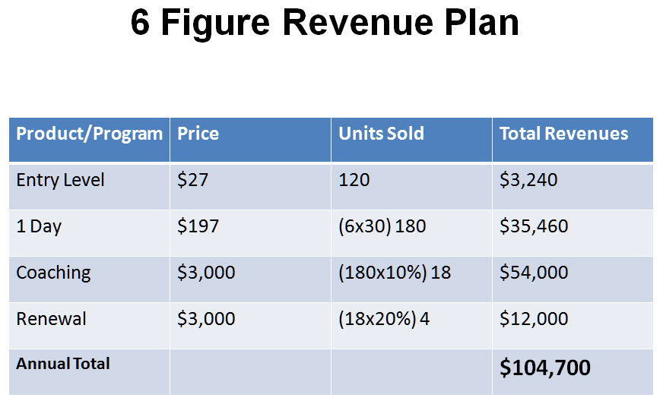
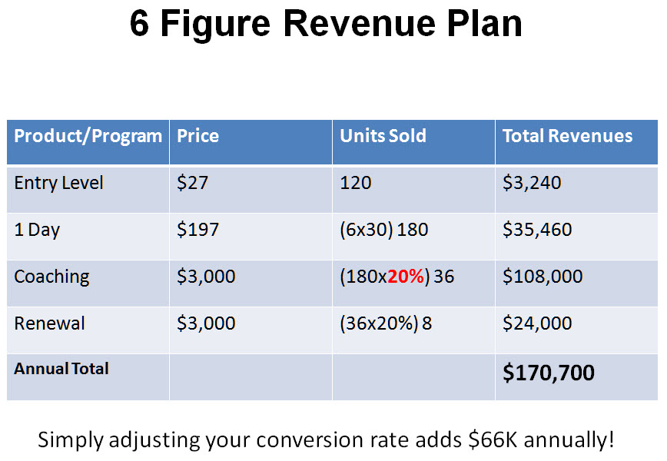
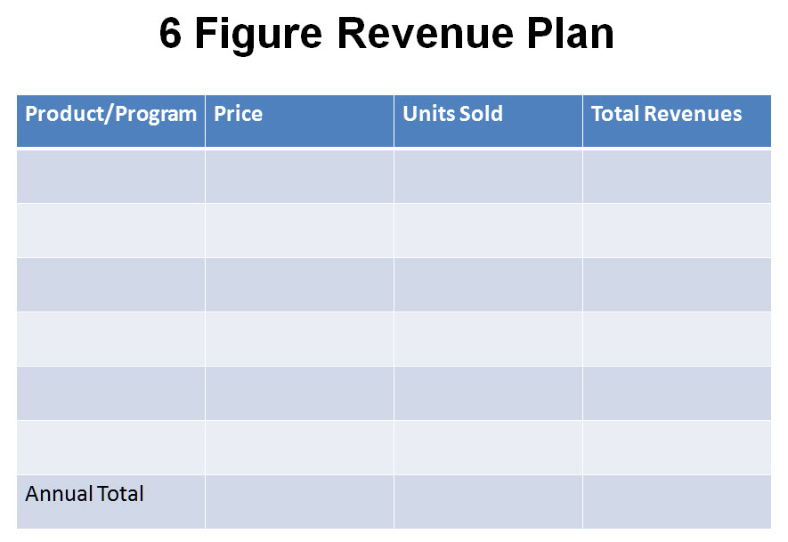
Guest #2
How to Use Strategy Sessions to Create 6 Figures This Year!

Notes:
__________________________________________________________________________________________________________________________________________________________________________________________________________________________________________________________________________________________________________________________________________________________________________________________________________________________________________________________________________________________________________________________________________________________________________________________________________________________________________________________________________________________________________________________________________________________________________________________________________________________________________________________________________________________________________________________________________________________________________________________

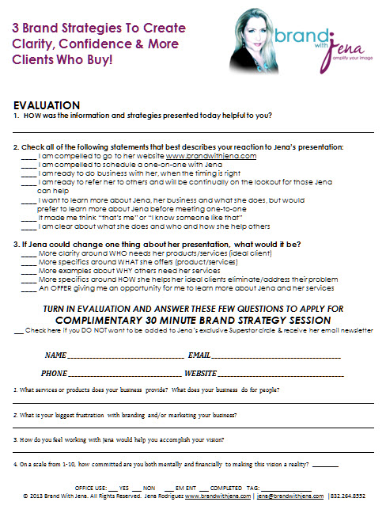Marketing: A Nasty 9 Letter Word that creates fear in the hearts of most entrepreneurs.

For entrepreneurs marketing has one main purpose – and that is lead generation. It is the job of your marketing to get people’s attention and to turn them into a lead and then it is the job of your sales strategies to convert their attention into a sale.

Where I see most entrepreneurs fail at marketing is that although marketing has one purpose – lead generation – it has 2 pieces.

- Creating the ____________________
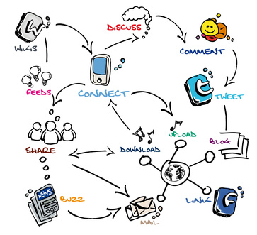
- Saying the _____________________

Touch Points

So you have probably heard that most prospects have to see something 7 to 8 times before they make a buying decision. I call those touch points. The bad news – I read an article the other day that with the advent of social media that number has increased to 10 to 12 times.

Saying the Right Thing

This seems to be a big frustration for most entrepreneurs. Earlier I said that you have to talk to them about what they already think they want. Not what you know they need. It is so much easier to get someone’s attention when they think they need you the minute they meet you.

How do you know what your ideal client thinks they want or need?

They are actually telling you what they need already. What I want you to do is write down what your clients are saying to you and to themselves. What are those fears that are keeping them up at night? Think about the things they have actually said to you. These things make great topics and titles for speaking, products or services. They also make great headlines for sales pages and opt-in forms.
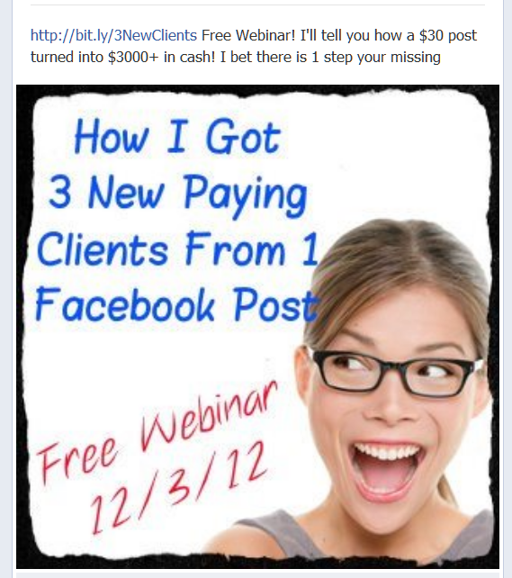
Do you know what people want? They want to be heard and understood and when you can have a conversation with someone and you are saying the things that they are thinking this makes it much easier for them to make a buying decision to work with you. This will improve your profitability.

Marketing Checklist

____1. Create Killer Image
____2. Post Image on Facebook, Twitter & Pinterest
____3. Create a Facebook Event – Invite Friends
____4. Write 2 or 3 Blog Posts
____5. Post Blog Posts on Facebook, LinkedIn, Twitter
& Pinterest
____6. Promote in Newsletter
____7. Create Email Marketing Campaign
____8. Book Speaking Engagements

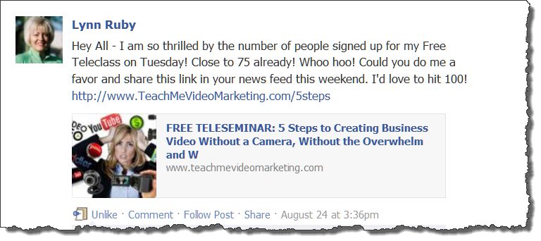

Guest #3
How to Increase Cash Flow by Offering Group Programs!

Notes:
__________________________________________________________________________________________________________________________________________________________________________________________________________________________________________________________________________________________________________________________________________________________________________________________________________________________________________________________________________________________________________________________________________________________________________________________________________________________________________________________________________________________________________________________________________________________________________________________________________________________________________________________________________________________________________________________________________________________________________________________

Hot Seat #1

__________________________________________________________________________________________________________________________________________________________________________________________________________________________________________________________________________________________________________________________________________________________________________________________________________________________________________________________________________________________________________________________________________________________________________________________________________________________________________________________________________________________________________________________________________________________________________________________________________________________________________________________________________________________________________________________________________________________________________________________

Hot Seat #2

__________________________________________________________________________________________________________________________________________________________________________________________________________________________________________________________________________________________________________________________________________________________________________________________________________________________________________________________________________________________________________________________________________________________________________________________________________________________________________________________________________________________________________________________________________________________________________________________________________________________________________________________________________________________________________________________________________________________________________________________

Hot Seat #3

__________________________________________________________________________________________________________________________________________________________________________________________________________________________________________________________________________________________________________________________________________________________________________________________________________________________________________________________________________________________________________________________________________________________________________________________________________________________________________________________________________________________________________________________________________________________________________________________________________________________________________________________________________________________________________________________________________________________________________________________

What To Do Next (Action Steps)

- __________________________________________________________________________________________________
- __________________________________________________________________________________________________
- __________________________________________________________________________________________________
- __________________________________________________________________________________________________
- __________________________________________________________________________________________________

Notes:
________________________________________________________________________________________________________________________________________________________________________________________________________________________________________________________________________________________________________________________________________________________________________________________________________________________________________

